2026

PROJECT TITLE: Email/SMS Spam Classifier
GROUP MEMBERS:
01 | Hazrat Bilal | 24PWBCS1345
02 | Haroon Ur Rashid | 24PWBCS1357
03 | Khalida Afghan | 24PWBCS1416
04 | Ilham Raza | 24PWBCS1259
SECTION: E
DEPARTMENT OF COMPUTER SCEINCE
UNIVERSITY OF ENGINEERING & TECHNOLOGY, PESHAWAR
PROJECT REPORT
SUBJECT: INTRODUCTION TO DATA SCIENCE
INSTRUCTOR: Rida Zarkash

Table of Contents
Abstract 2
Introduction 3
Problem Statement 4
Objectives 5
Methodology 6
Dataset 6
1.Data Cleaning 7
2. Exploratory Data Analysis (EDA) 10
1. Class Distribution 10
2. Text Length Analysis Three new numerical features were created from each message: 11
3. Descriptive Statistics Statistical summaries (count, mean, standard deviation, minimum, maximum, and quartiles) were generated for: 12
4. Character Distribution 14
5. Word Distribution 15
6. Pair Plot Analysis 16
7. Correlation Heatmap Analysis 17
3. Text Preprocessing 18
4. Feature Extraction 19
a. Spam Message Word Cloud 19
b. Ham Message Word Cloud 20
4. Model Building 22
5. Model Evaluation 23
6. Model Selection 24
7. Advanced Model Development 25
8. Model Saving 26
9. Deployment 26
Conclusion 27

Abstract
This project presents an SMS Spam Detection system using Machine Learning and Natural Language Processing (NLP). The objective is to automatically classify SMS messages as Spam or Ham, helping users filter unwanted messages efficiently.
The dataset was cleaned by removing unnecessary columns and duplicate records. Text preprocessing techniques including lowercase conversion, tokenization, stop-word removal, punctuation removal, and stemming were applied to improve text quality.
The processed text was transformed into numerical features using the TF-IDF vectorizer. Three Naive Bayes classifiers were trained and evaluated using accuracy, precision, and confusion matrix.
Among them, the Multinomial Naive Bayes classifier produced the best results and was selected as the final model. The trained model was saved using Pickle and deployed as a Streamlit web application for real-time spam message prediction.

Introduction
Spam messages are unsolicited messages that often contain advertisements, scams, fraudulent offers, or phishing attempts. Due to the increasing number of spam messages, manually filtering them has become difficult and time-consuming.
Machine Learning provides an effective solution by automatically classifying messages based on their content. This project develops an SMS Spam Detection system using Natural Language Processing and Machine Learning techniques.
The text messages are cleaned and converted into numerical features using the TF-IDF vectorization method. Multiple Naive Bayes algorithms are trained and compared to identify the most suitable model.
The Multinomial Naive Bayes classifier achieved the highest performance and was selected for deployment. The final system is implemented as a Streamlit web application that allows users to quickly determine whether an SMS message is Spam or Ham.

Problem Statement
The increasing number of spam SMS messages exposes users to fraud, phishing attacks, and unwanted advertisements. There is a need for an automated system that can accurately classify messages as Spam or Ham to improve communication security.

Objectives
- Build an SMS spam detection model.
- Clean and preprocess text data.
- Perform exploratory data analysis.
- Convert text into TF-IDF features.
- Train and compare Naive Bayes classifiers.
- Evaluate model performance.
- Deploy the model using Streamlit.

Methodology

Dataset
- SMS Spam Collection Dataset
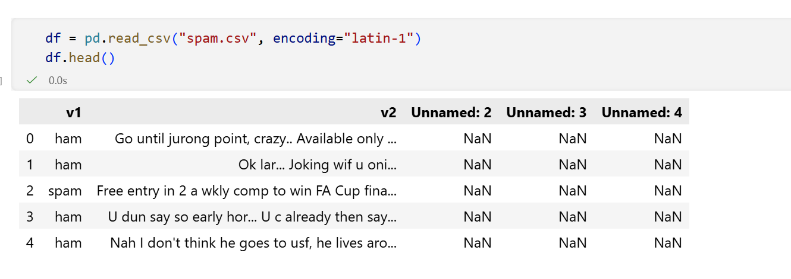

1.Data Cleaning

The dataset was cleaned to improve its quality and prepare it for machine learning. The following steps were performed:
- Removed unnecessary columns (Unnamed: 2, Unnamed: 3, Unnamed: 4) containing mostly null values.
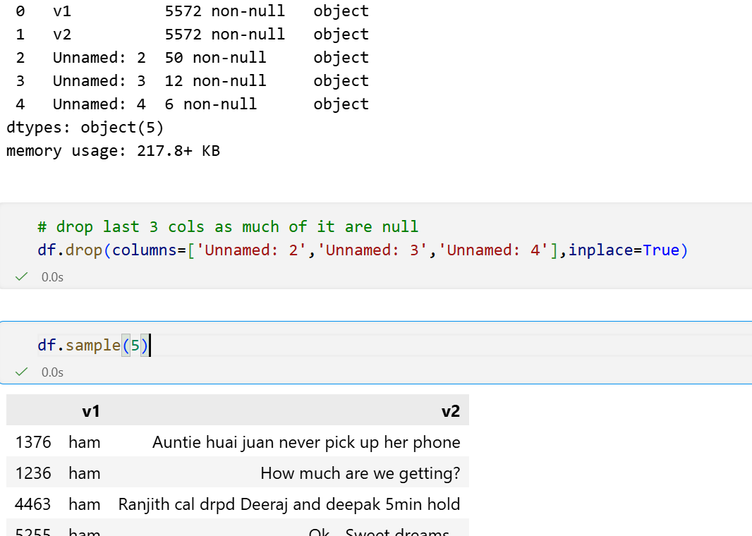

- Renamed the columns from v1 and v2 to target and text for better readability.
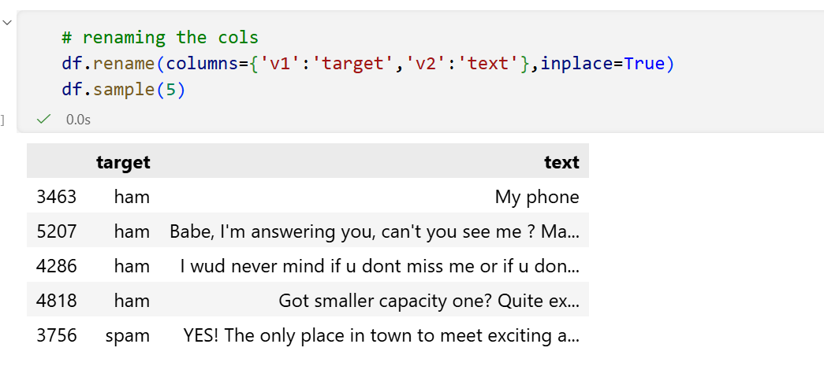

- Encoded the target labels using Label Encoding (Ham = 0, Spam = 1).
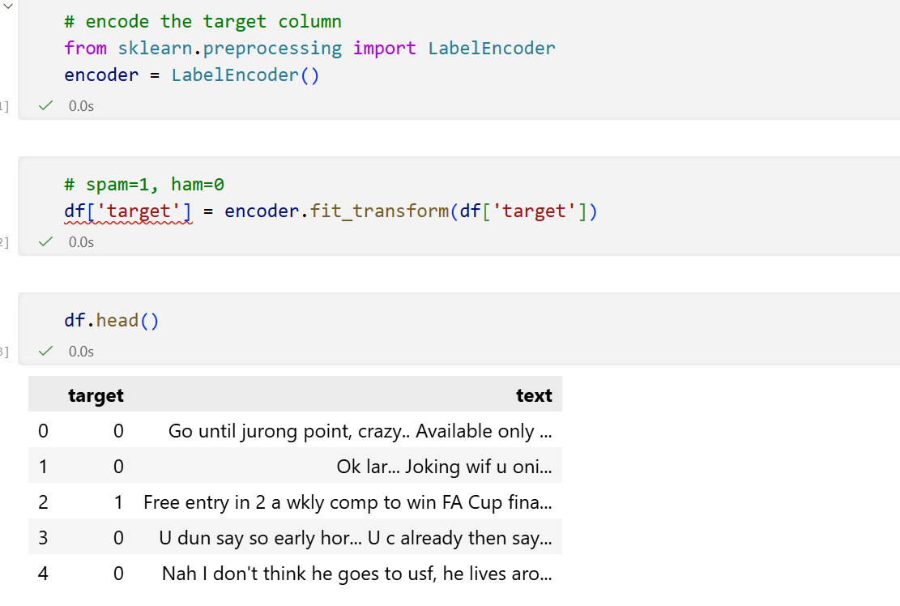

- Checked for missing values (no missing values were found).
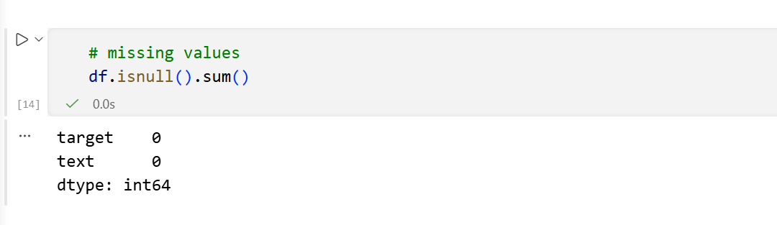

- Removed duplicate records to ensure a clean and consistent dataset.

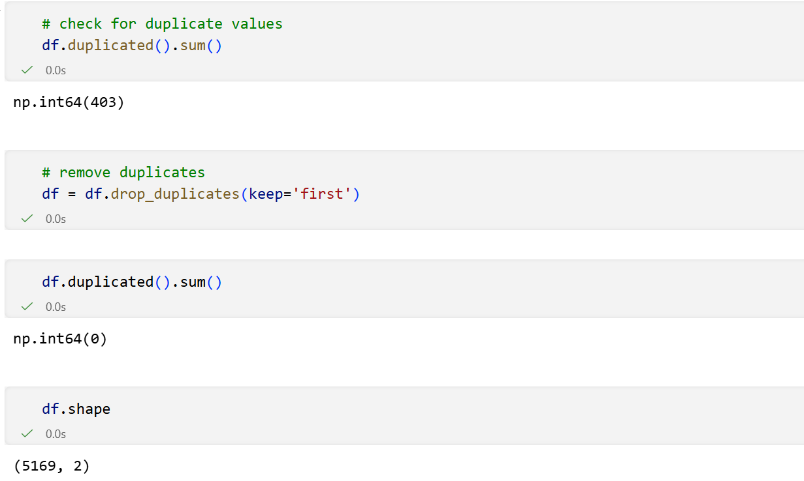

2. Exploratory Data Analysis (EDA)
Exploratory Data Analysis (EDA) was performed to understand the characteristics of the SMS dataset and identify patterns between spam and ham messages before building the machine learning models.

1. Class Distribution
- Counted the number of spam and ham messages.
- Visualized the distribution using a pie chart.
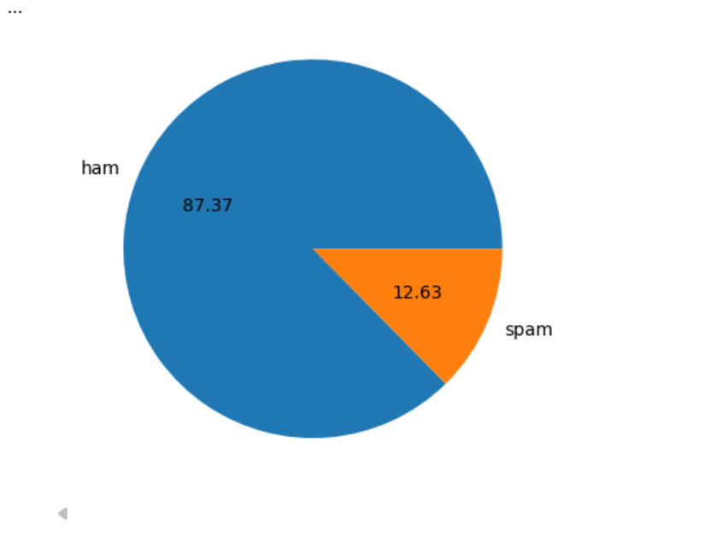
- The pie chart shows the distribution of SMS messages in the dataset. Approximately 87.37% of the messages are Ham (non-spam), while 12.63% are Spam. This indicates that the dataset is imbalanced, with ham messages significantly outnumbering spam messages. This imbalance should be considered during model development and evaluation to ensure accurate spam detection.

2. Text Length Analysis
Three new numerical features were created from each message:
- Number of Characters: Total characters in each SMS.
- Number of Words: Total words in each SMS.
- Number of Sentences: Total sentences in each SMS.
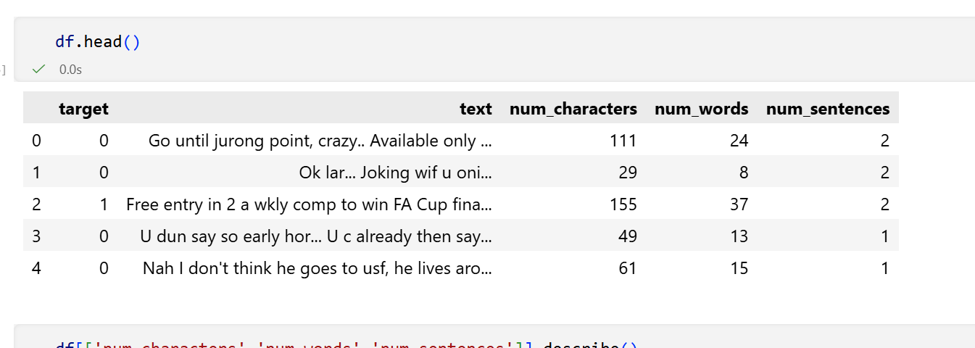

3. Descriptive Statistics
Statistical summaries (count, mean, standard deviation, minimum, maximum, and quartiles) were generated for:
- Entire dataset
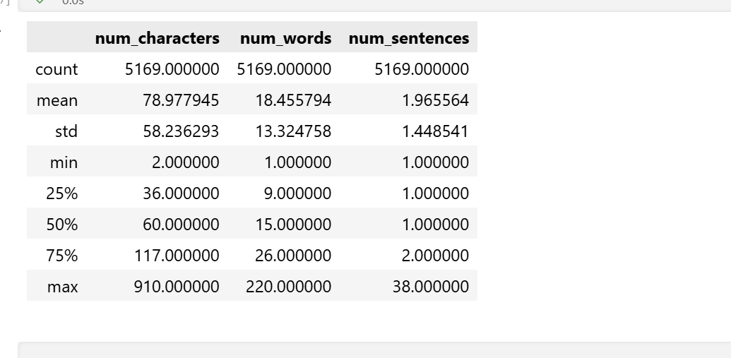
- Ham messages
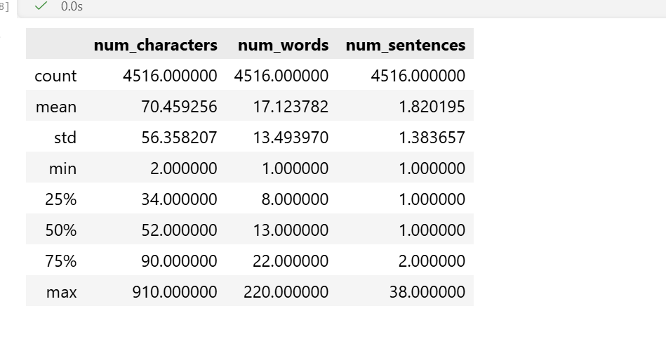

- Spam messages
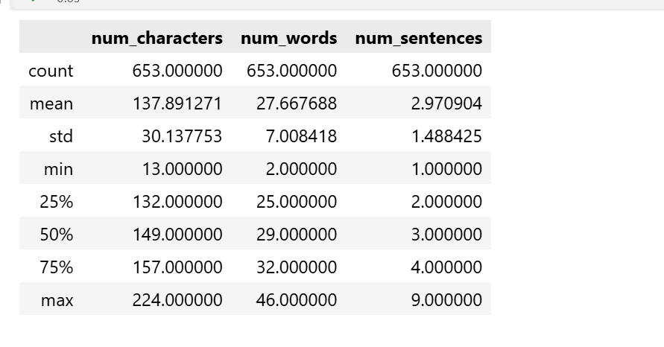

This comparison showed that spam messages generally contain more characters, words, and sentences than ham messages.

4. Character Distribution
- Histograms were plotted to compare the distribution of the number of characters in spam and ham messages.
- Spam messages were generally longer than ham messages.
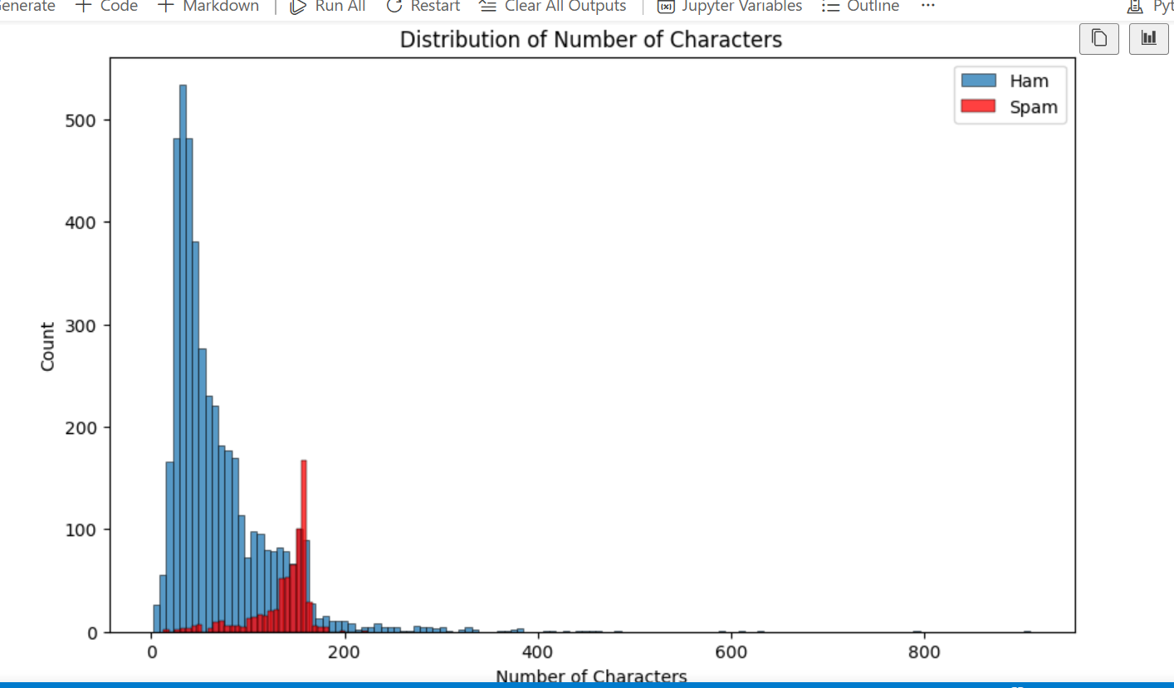

The histogram compared the number of characters in Ham and Spam messages. It showed that ham messages were generally shorter, with most containing fewer than 100 characters. In contrast, spam messages were generally longer, with a higher concentration between 100 and 170 characters. This indicated that the number of characters was a useful feature for distinguishing spam from ham messages.

5. Word Distribution
- Histograms were created to compare the number of words in spam and ham messages.
- Spam messages tended to contain more words on average.
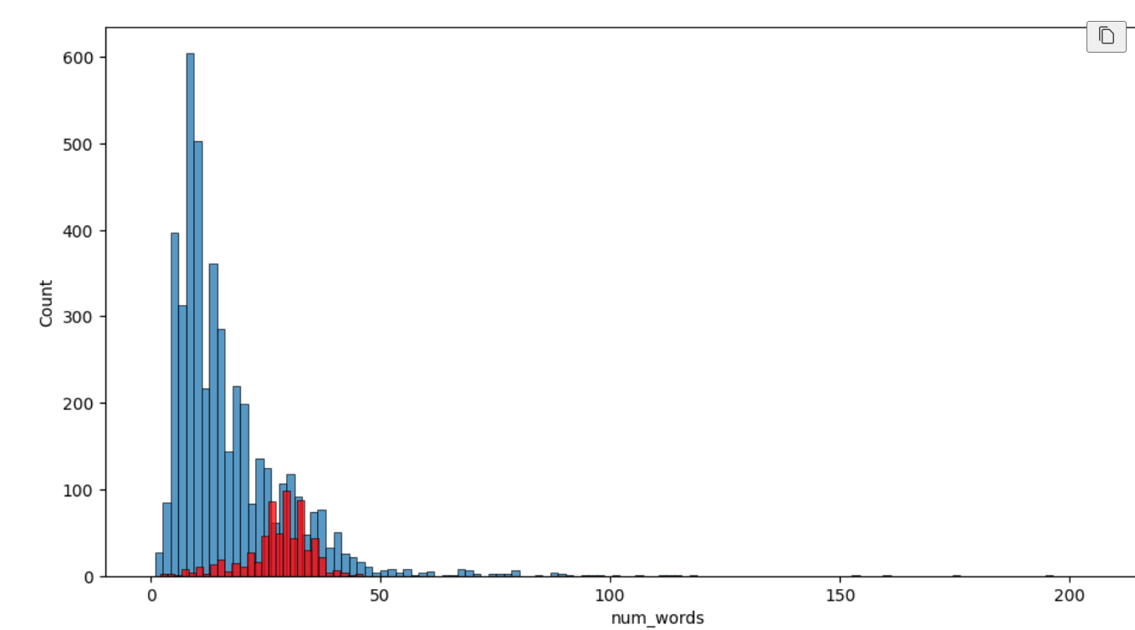

The histogram compared the number of words in Ham and Spam messages. It showed that ham messages generally contained fewer words, while spam messages tended to contain a higher number of words. Most spam messages were concentrated between 20 and 35 words, whereas ham messages mostly contained 5 to 20 words. This indicated that the number of words was an important feature for distinguishing spam from ham messages.

6. Pair Plot Analysis
- Pair plot generated using the numerical features.
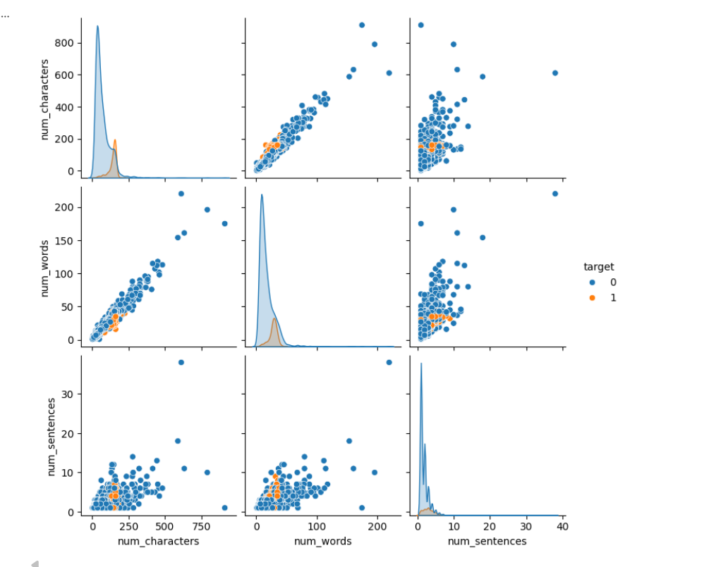

The pair plot shows the relationships among the numerical features: number of characters, number of words, and number of sentences. It indicates a positive relationship between the number of characters and the number of words, as messages with more characters generally contain more words. The plot also shows that spam messages tend to have higher values for these features than ham messages. These patterns suggest that the numerical features are useful for distinguishing spam from ham messages.

7. Correlation Heatmap Analysis
The correlation heatmap shows the relationships between the numerical features in the dataset. It indicates a strong positive correlation (0.97) between the number of characters and the number of words, meaning that longer messages generally contain more words. The number of sentences also shows a moderate positive correlation with both characters (0.62) and words (0.68). The target variable has a weak positive correlation with these features, suggesting that message length contributes to spam detection but is not the only determining factor.

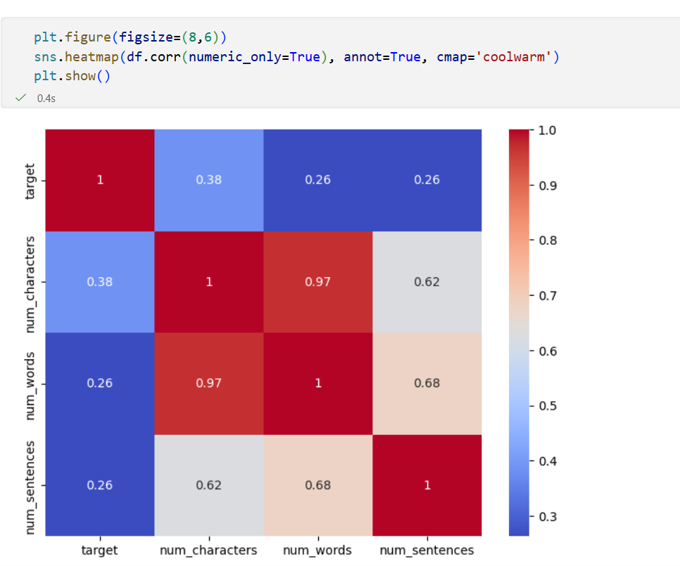

3. Text Preprocessing
The SMS messages were preprocessed using Natural Language Processing (NLP) techniques to prepare the text for machine learning. The following preprocessing steps were applied:
- All text was converted to lowercase to maintain consistency.
- The messages were tokenized into individual words.
- Special characters and non-alphanumeric values were removed.
- English stop words and punctuation were removed to eliminate unnecessary words.
- Porter Stemming was applied to reduce words to their root form (e.g., playing → play, loved → love).

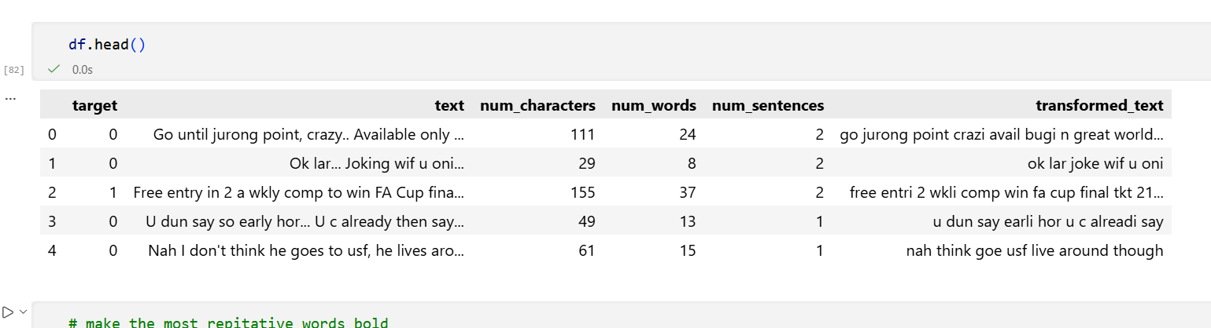

These preprocessing steps reduced noise, standardized the text, and improved the quality of features used for spam classification.

4. Feature Extraction
The cleaned text was converted into numerical form using the TF-IDF Vectorizer.
  - Spam Message Word Cloud
The word cloud shows the most frequently occurring words in spam messages. Words such as "call," "free," "txt," "text," "mobil," "claim," "reply," and "stop" appear more prominently, indicating their higher frequency. These words reflect the promotional and advertising nature of spam messages and help identify common spam-related patterns.

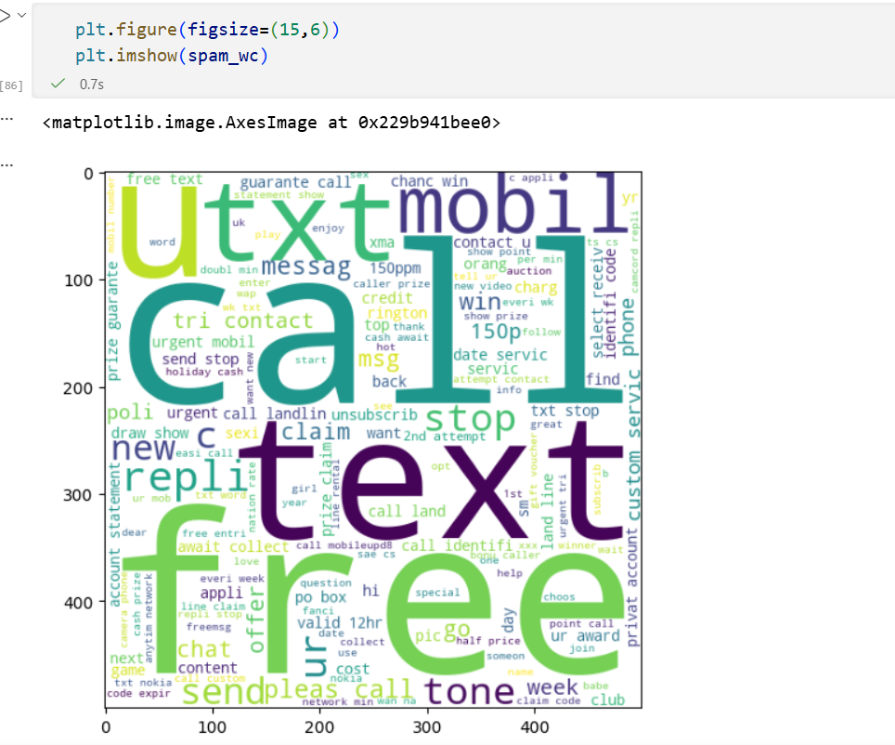

  - Ham Message Word Cloud
The word cloud shows the most frequently occurring words in ham (non-spam) messages. Common words such as "u," "go," "come," "love," "ok," "know," "time," and "good" appear more prominently. These words represent everyday conversations and personal communication, highlighting the difference between legitimate and spam messages.

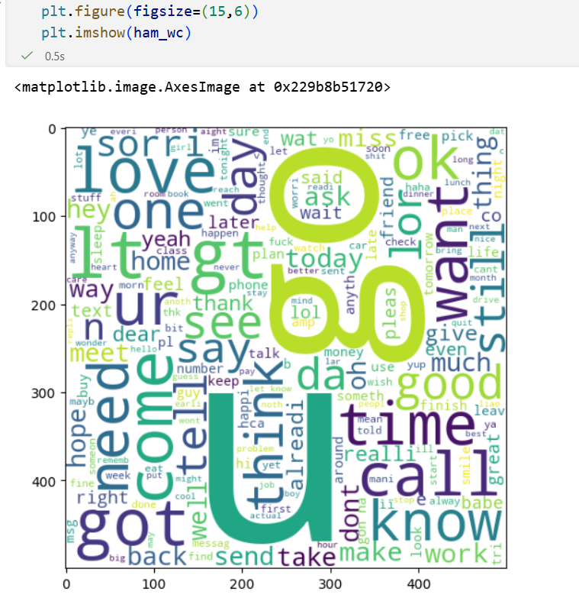

Visualization: Top 30 Most Frequent Words in Spam Messages

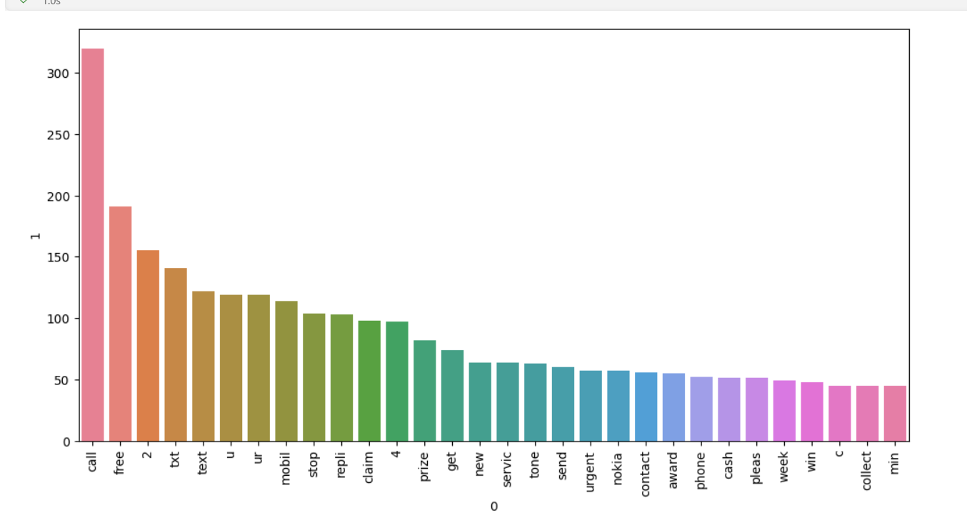

Visualization: Top 30 Most Frequent Words in Ham Messages

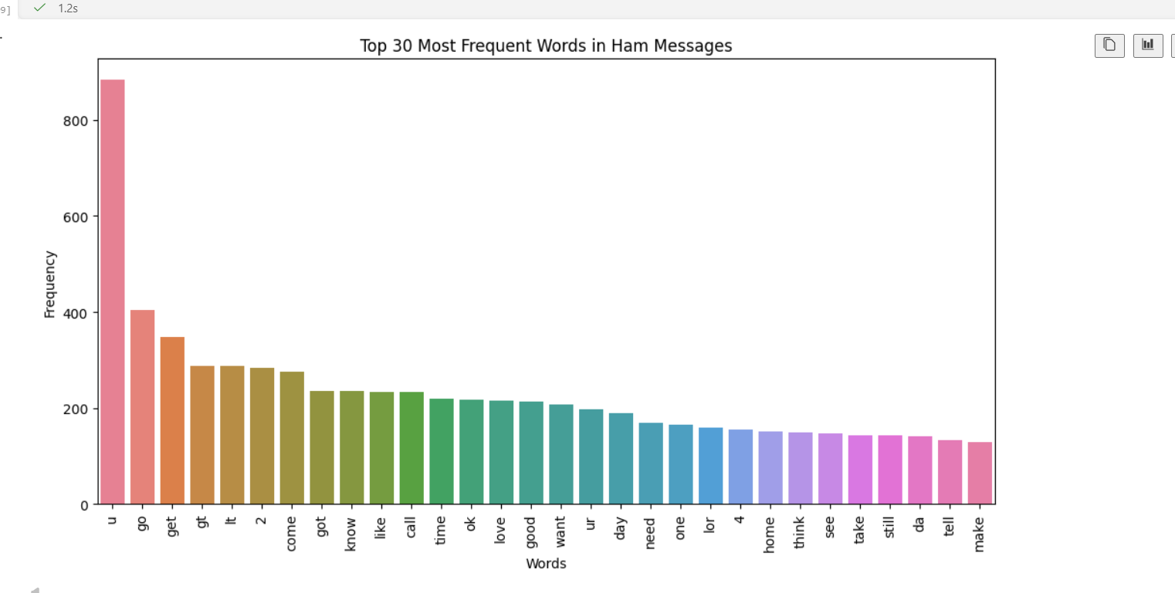

4. Model Building
The preprocessed SMS messages were converted into numerical features using the TF-IDF Vectorizer. The dataset was then divided into 80% training data and 20% testing data to train and evaluate the models.
Three Naïve Bayes classifiers were implemented and compared:
- Gaussian Naïve Bayes (GNB)
- Multinomial Naïve Bayes (MNB)
- Bernoulli Naïve Bayes (BNB)
The performance of each model was evaluated using Accuracy, Precision, and the Confusion Matrix. Among the three models, Multinomial Naïve Bayes achieved the best performance and was selected as the baseline model for the spam detection system.

5. Model Evaluation
The three Naïve Bayes classifiers were evaluated using Accuracy, Precision, and the Confusion Matrix. Since the SMS spam dataset is imbalanced, precision was considered a more important evaluation metric than accuracy. A high precision score indicates that the model correctly identifies spam messages while minimizing false positive predictions (i.e., legitimate messages incorrectly classified as spam).
The evaluation results are summarized below:
Model | Accuracy | Precision
Gaussian Naïve Bayes | 87.33% | 51.60%
Multinomial Naïve Bayes | 97.10% | 100.00%
Bernoulli Naïve Bayes | 98.36% | 99.19%

6. Model Selection
Although Bernoulli Naïve Bayes achieved the highest accuracy (98.36%), Multinomial Naïve Bayes was selected as the final baseline model because it achieved a precision of 100%. In an imbalanced spam detection problem, precision is more critical than accuracy because it reduces the number of legitimate (ham) messages that are incorrectly classified as spam. Therefore, Multinomial Naïve Bayes was chosen as the baseline model for further development.

7. Advanced Model Development
To further improve the performance of the SMS Spam Detection system, two advanced machine learning algorithms were implemented and evaluated using the TF-IDF feature vectors.
The models used were:
- Support Vector Machine (SVM)
- Random Forest (RF)
Both models were evaluated using Accuracy and Precision. The results are presented below.
Model | Accuracy | Precision
Support Vector Machine (SVM) | 97.58% | 97.48%
Random Forest (RF) | 97.68% | 97.50%

Discussion
Although Random Forest achieved a slightly higher accuracy (97.68%), Multinomial Naïve Bayes remained the preferred model because it achieved 100% precision, meaning it did not incorrectly classify any legitimate (ham) messages as spam. Since the SMS spam dataset is imbalanced, precision is more important than a small improvement in accuracy. Therefore, Multinomial Naïve Bayes performed consistently well across all evaluation criteria and remained the final model selected for deployment.

8. Model Saving
The final Multinomial Naïve Bayes model and the TF-IDF Vectorizer were saved using the Pickle library for deployment.
Saved Files:
- model.pkl
- vectorizer.pkl

9. Deployment
The final model was deployed as an interactive Streamlit web application. The application allows users to enter an SMS or email message into the text box and click the "Predict" button. The input text is first preprocessed and converted into TF-IDF features, after which the trained model predicts whether the message is Spam or Not Spam (Ham). This provides users with a simple and real-time spam detection system.

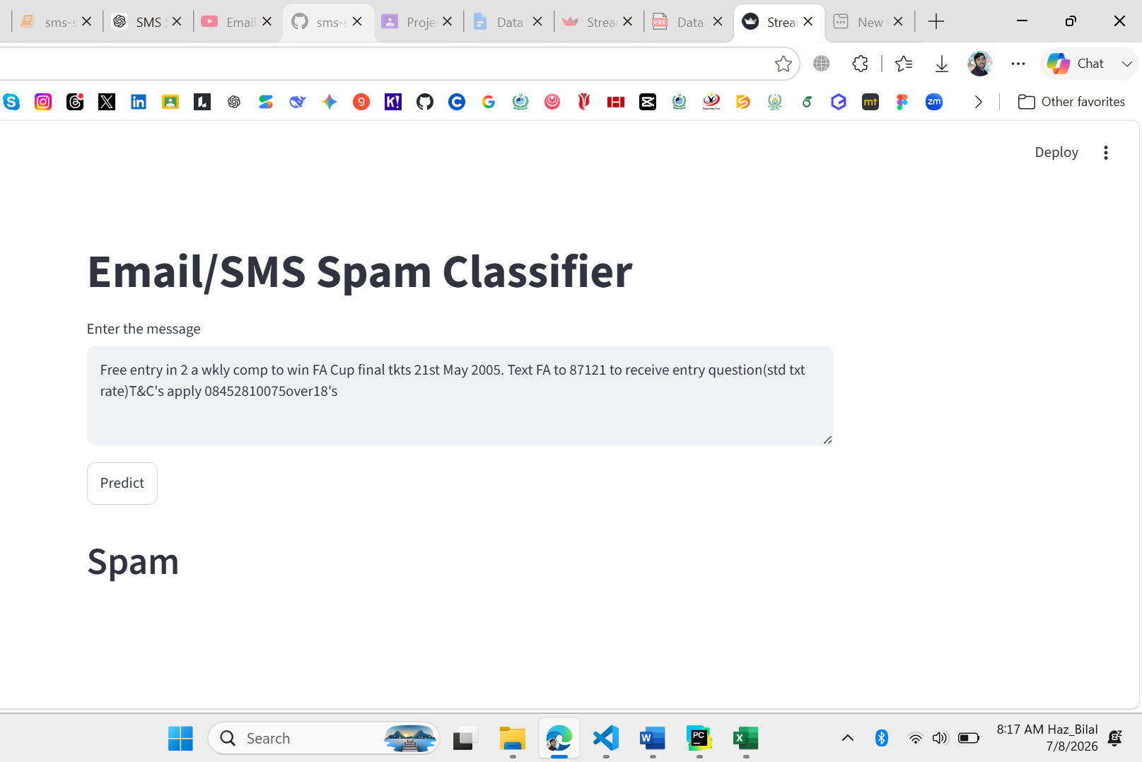
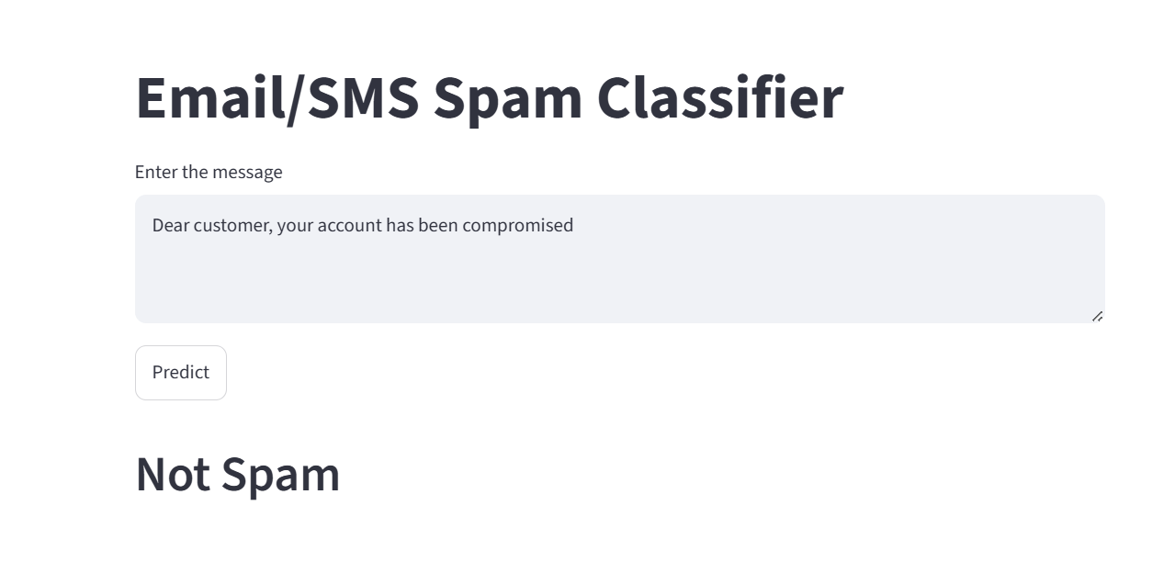S

Conclusion
This project successfully developed an SMS Spam Detection System using Natural Language Processing (NLP) and Machine Learning techniques. The dataset was cleaned, explored, and preprocessed before converting the text into numerical features using the TF-IDF Vectorizer.
Three Naïve Bayes classifiers were evaluated, and Multinomial Naïve Bayes was selected as the final model because it achieved 100% precision, making it the most suitable choice for the imbalanced dataset.
Advanced models, including Support Vector Machine (SVM) and Random Forest (RF), were also implemented for comparison, but Multinomial Naïve Bayes remained the preferred model due to its superior precision.
Finally, the trained model was deployed as a Streamlit web application, allowing users to classify SMS or email messages as Spam or Not Spam (Ham) in real time. The project demonstrated the complete end-to-end data science pipeline, from data preprocessing to model deployment, and provided an effective solution for spam message detection.
THE END

